**Psychological Safety Team Performance Workshop**

There is a misconception that psychological safety is about being “soft” or accepting lower standards. This is not the case. In fact, a culture of psychological safety necessitates and enables higher standards of performance, delivery, and quality.

The diagram below illustrates one way of modelling your team’s culture, by plotting their psychological safety against their drive to perform. Here’s what each of the quadrants mean:

* **Apathy** - A team with **neither** psychological safety **nor** a drive to perform will be unhappy and reluctant to work.
* **Comfort Zone** - A team with **high** psychological safety but **without** a drive to succeed will feel safe, but will not reach their potential for performance.
* **Anxiety** - If a team has **low** psychological safety but is **highly** driven, the result can often be high levels of anxiety. This can often be seen in highly pressurised sales teams where team members are pitted against each other for results.
* **High Performance** - The optimum team resides in this zone. They feel a great deal of psychological safety and demonstrate a strong drive to deliver results. This is also known as the “learning zone”, because team members are empowered to innovate, experiment and learn from mistakes.

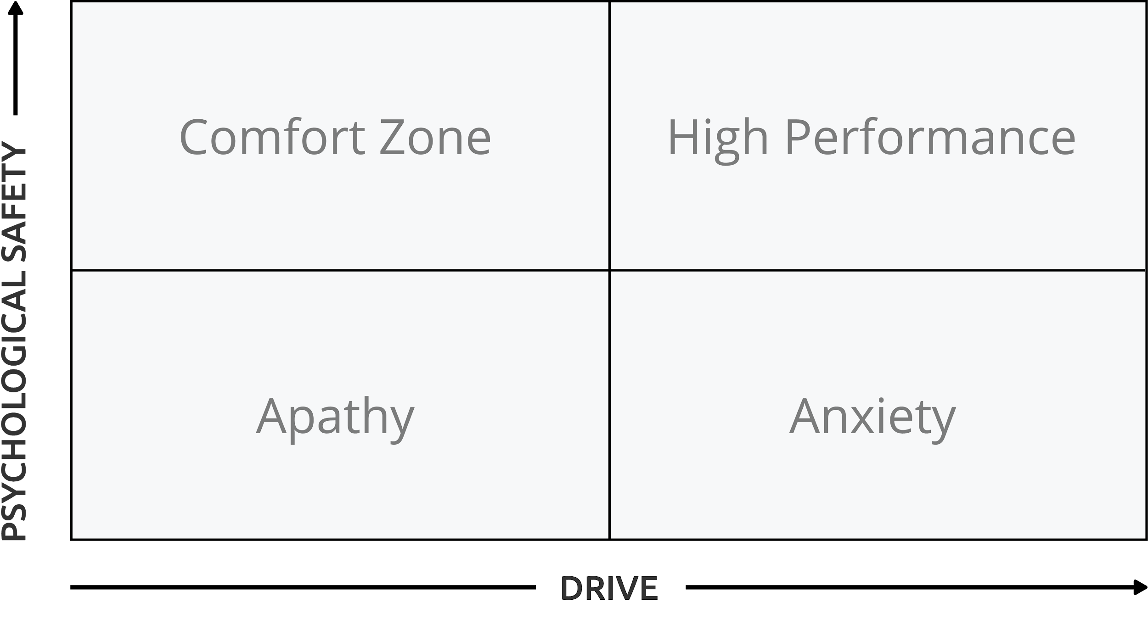

**Running a Team Performance Workshop**

1. Draw the quadrant diagram on a whiteboard or print out individual copies of the included *Psychological Safety and Performance Quadrant* (item G).
2. Talk with your team to explain what the four quadrants represent. You can bring in examples of times you’ve experienced working in different quadrants in the past, maybe in other teams.
3. Ask team members to share examples of where they’ve felt in different parts of this quadrant in the past - this will encourage team members to engage with the model and promote openness and shared vulnerability. Try to ensure everyone has spoken at least once before moving to the next step.
4. Hand out printed copies of this quadrant and ask people to place a blue dot where they feel they are right now, and a green dot where they would like to be. Place the copies in a pile face down to allow for anonymity. At a later stage, you may want to re-run this exercise with team members placing a dot on the whiteboard in view of everyone, but to begin with, anonymity provides the safety to be truthful.
5. Collect the completed copies and either shuffle and share them, or place corresponding dots on the white board for everyone to see.
6. Discuss the results as a team. Are they expected or unexpected, good or bad, broadly aligned or varied? Give everyone a chance to comment and reflect.
7. Ask what micro-steps would help the team to move forward from here. Ask team members to make suggestions verbally or write them on post-its to stick up, then put asterisks or coloured stickers on others’ suggestions that they support.
8. Agree a number of steps that the whole team, individual members, or the leader of the team will take to move the team towards, or further into, the High Performance quadrant. Document and share these actions to engender commitment.
9. Schedule a follow up session to check in on progress. This should be at least 2 months to allow time for improvement, but no more than 6 months in order to maintain momentum.

Finally, ask for feedback from your team regarding how they felt this exercise went, what value they gained from it, and how it could be improved next time.

For further information about this model, see “The Fearless Organization” by Amy Edmondson.